Fire resistance testing of doors according to EN 1634-1

To be held on 29 and 30 June 2017 at PAVUS in Prague, Czech Republic

Workshop structure
The purpose of this workshop is to investigate the difficulties and discrepancies in the understanding of the standard requirements revealed during the EGOLF theoretical round-robin on doors (results released in March 2017).
The main reasons are related to the presence of any discrete area of different thermal insulation and to the location of unexposed face thermocouples. The rules laid down by the test standard EN 1634-1 prove to be not sufficiently adequate and clear, confusing, and even may conflict with each other.

Outcome of the workshop
A report of the workshop will be drafted containing all topics discussed and any solutions suggested.
These solutions will be proposed to CEN TC127 WG3 for standard revision and to EGOLF as recommendations.

We suggest you bring with you:
- Copy of EN 1634-1:2014 standard
- Copy of EN 1363-1:2012 standard
- Copy of the report of the EGOLF theoretical round-robin on doors (nr. TC2 16-1, to be published on EGOLF website soon)

Agenda
29 June: 13:00 – 17:30
30 June: 09:00 – 13:00

Cost
Participation to the workshop is free of charge.

Registration
To participate to this workshop, you should have a good knowledge of the test standard EN 1634-1:2014 and/or be involved in standards revision process within CEN TC127 WG3.
In order to ensure efficiency of the workshop, the number of participants is limited to 15. Acceptance of participants will be on first come first serve basis.
If less than 8 people register, the workshop will be rescheduled or cancelled.
Please contact the workshop administrator by e-mail (see below) to apply to attend the workshop. Deadline for registration is 28 April 2017.

Contact details
Workshop administrator:
Fabien Dumont
E-mail: fabien.dumont@ulg.ac.be
Phone: +32 (0)4 366 9294

Workshop venue
PAVUS, a.s.
Prosecká 412/74
190 00 Praha 9
Czech Republic

Contact at PAVUS (only if necessary):
Jaroslav Dufek
E-mail: dufek@pavus.cz
Phone: + 420 286 019 586
Website: www.pavus.cz

Access to the meeting room
Geographical location of the meeting room:
Latitude - 50°7´12.984"N , Longitude - 14°30´18.772"E

The meeting room is accessible:
- from any area of the city:
  - by metro: line C, get off at station "Prosek" and then walk 5 minutes
  - by bus:
    - from metro station "Palmovka" on line B, take the bus nr. 140 or 185 and get off at the stop "Nový Prosek"
    - from metro station "Vysočanská" on line B, take the bus nr. 136 or 195 and get off at the stop "Nový Prosek"
- from the airport:
  - by taxi
  - by bus and metro: take the bus nr. 100 from the Airpor Vaclava Havla to metro station "Zličín" on line B, take the metro and get off at station "Palmovka" or "Vysočanska", and then see above

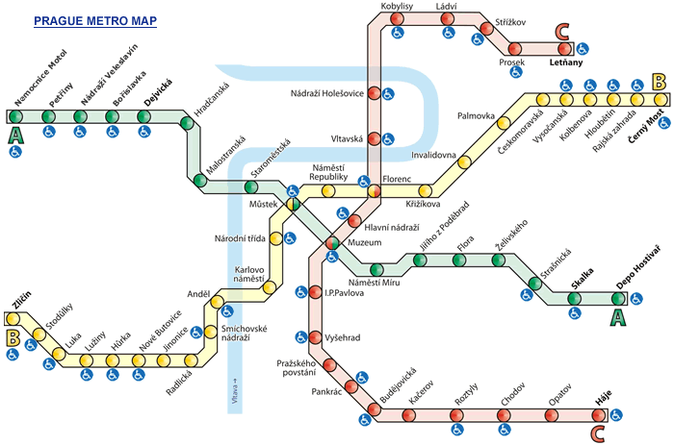

Hotels in Prague
Coming soon…

